Excretory System Worksheet

6. Add the following labels to the diagram below of the urinary system of a mammal.
kidney; bladder; ureters; urethra, renal artery and vein, caudal vena cava, sphincter.
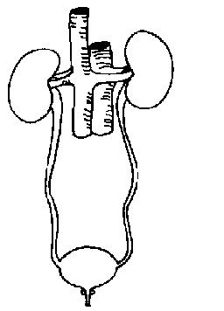

7. Match the organ with the function in the table below.
Kidney; cortex; ureter; bladder; renal vein; urethra; capsule; medulla; renal pelvis; renal artery; sphincter

Organ | Function
 | Carries urine from the bladder to the outside of the body
 | Carries deoxygenated blood away from the kidney
 | The inner region of the kidney
 | Muscle that opens to allow urine to be removed from bladder
 | The outer region of the kidney
 | Carries oxygenated blood to the kidney
 | The part of the kidney that collects the urine before it passes down the ureter
 | The tough fibrous coat around the kidney
 | Stores urine before it is removed from body
 | The tube that carries urine away from the kidney
 | Converts blood to urine

8. Label the structures of a kidney

9. These are functions of the kidney: (Circle 4)
a. breaking down damaged blood cells
b. controlling the concentration of water in the blood
c. Removing urea from the blood
d. Removing carbon dioxide from the blood
e. Removing glucose from the blood
f. Keeping the blood at the right pH (acidity/alkalinity)
g. Digesting food
h. Controlling the concentration of salts like sodium and potassium chloride in the blood

10. Label the structures of a nephron

11. Match the part of the kidney tubule with its function.
collecting duct; loop of Henle; distal convoluted tubule; glomerulus; proximal convoluted tubule; renal artery; Bowman’s capsule; Antidiuretic hormone or ADH.

Part of tubule | Function
 | Carries blood to the kidney
 | The hormone that is involved in producing concentrated urine
 | Cup shaped structure through which the fluid part of the blood is filtered
 | Where the majority of water is extracted from the urine
 | Looped portion of the tubule. Important for helping concentrate the urine
 | Where hydrogen and potassium ions are secreted into the urine
 | Glucose, salts, water and amino acids are reabsorbed into the blood capillaries here
 | Tuft of capillaries carrying high pressure blood

http://www.scribd.com/doc/7247651/Chapter-11-Excretion-Tutorial-Worksheet
http://wikieducator.org/The_Anatomy_and_Physiology_of_Animals/Excretory_System_Worksheet

