Name:

CIRCULATORY WEBQUEST
L.E. Biology
Period:

(PART I: Introduction, Parts of the Heart, and Pathway of Blood)

http://www.smm.org/heart/heart/steth.htm
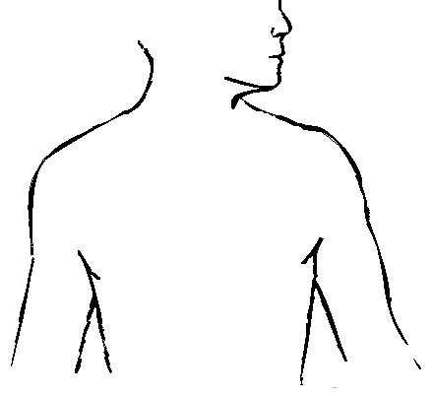
- Where is your heart located? Use the stethoscope to find the location of the heartbeat and place a star on the body below where the heart is located.

http://www.smm.org/heart/heart/circ.htm
- Observe the heart pumping blood. Which additional organ works with your circulatory system to give oxygen to all of your cells?

- Use google images and label the following diagram of the heart

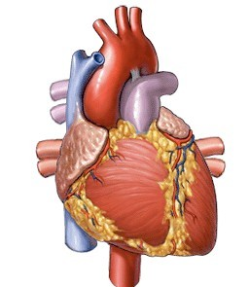

WORD BANK:  Superior Vena Cava | Left Ventricle | Right Atrium
Inferior Vena Cava | Right Ventricle | Aorta
Left Atrium | Pulmonary Vein | Pulmonary Artery

4. Flash Cards on Parts of the Heart
http://quizlet.com/1969655/parts-of-the-heart-and-their-functions-flash-cards/
Step One: View the flash cards several times.
Step Two: Press on the box that is titled "LEARN." Try to type in the correct term that matches each description.
Step Three: Press on the box that is titled "TEST." When you are done with the test, record the number of questions you had that where correct and the number that where incorrect. In addition, have your teacher sign the box that says "Completed Practice Test."

Number of Questions Correct /14

Number of Questions Incorrect /14 Completed Practice Test (Teacher's Signature)

NOTE: You do not need to know all of the terms in this activity. See the list below:

Terms you ARE responsible for: Terms you are NOT responsible for:
Aorta Pulmonary Vein Coronary Vessels
Pulmonary Artery Left Ventricle Bicuspid Valve
Oxygenated Right Ventricle Tricuspid Valve Deoxygenated Arteries
Right Atrium Veins Vena Cava

http://www.purposegames.com/game/label-the-hearts-parts-quiz
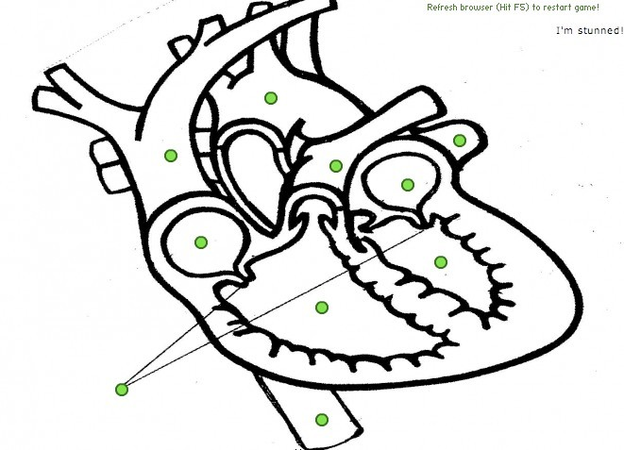
- Practice will make perfect! Play the game to identify the parts of the heart below. NOTE: You must click on "START" first! Call over Ms. Jantzi or Mr Fortney and a prize will be awarded to the student who can do it the fastest with 100% accuracy!

How long did the game take you? (Does not matter how long as long as you can identify all of the parts!)

http://kidshealth.org/parent/general/body_basics/heart.html
About the Heart and Circulatory System
- What are the three main parts of the circulatory system?

A. B. C.

- In class, during brain pop, we learned about three types of circulation. This website does not discuss coronary circulation, the type of circulation movement of blood in and around the heart. Define the other types of circulation discussed on the site.

Pulmonary Circulation:

Systemic Circulation:

Click on "Body Basics: Heart" View the animation of blood flow through the heart and fill in the blanks below.
When blood circulates in the body, it enters the heart through the , [asses through to the , and flows out through the to the -where it picks up and gets rid of
. From the lungs, blood returns to the

and enters the where it is pumped to the body through the
http://www.webmd.com/hypertension-high-blood-pressure/guide/blood-pressure-causes
What causes high blood pressure? List four causes and identify if any of these causes are preventable or controllable.

Cause | Preventable (Yes or No)

http://www.wisc-online.com/objects/index_tj.asp?objID=AP14604
RED BLOOD CELLS

Blood is called the “River of ”because it carries:

- is the FLUID COMPONENT of blood and makes up %.

- makes up the remaining percentage of blood.
- Red Blood Cells are also known as . What is their main function?

- How are Red Blood Cells designed to perform this function?

- What is HYPOXIA or CYONOTIC mean?

- How long do Red Blood Cells live for?

http://www.wisc-online.com/objects/index_tj.asp?objID=AP14704

WHITE BLOOD CELLS

- White blood cells are also known as .

- Almost all blood cells are formed from , a type of stem cell found in the

.

- White blood cells called MACROPHAGES, perfom PHAGOCYTOSIS…what is this process?

Draw a picture to support your answer:

http://www.medindia.net/know_ur_body/cirsystem.asp
- Every second, are destroyed in the human body.

- Human blood is . It is the ; a pigment present in the that is responsible for the color of the blood.

- is nothing but the sound produced by the closure of of the heart when the blood is pushed through its chamber.

- A 's heart beat is faster than that of a ________ 's.

- The human heart continues to even after it is taken out of the body or cut in to pieces.

http://www.sciencekids.co.nz/sciencefacts/humanbody/blood.html

- Blood makes up around of the weight of a human body.

- Blood contains , and .

- These blood cells float in a yellow liquid called blood . Blood is made up of water and also contains various nutrients, electrolytes, gases, proteins, glucose and hormones.

